# Booking a meeting room

**Note**: Teaching rooms must be booked through the CBE Facilities & services helpdesk.

## Checking available rooms

Open your Calendar in Outlook and Click on **New Meeting**.

You will need to have MS Office 2010 or later for this to work. If you have Office 2007 or earlier, put in an IT helpdesk request on <https://itservicedesk.anu.edu.au/>

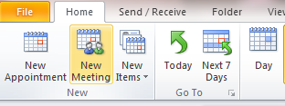

Enter your proposed date and time. Note: That the ‘all-day event’ checkbox will return no results

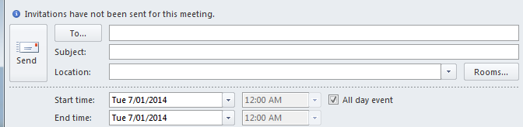

Add any other participants in the **To…** field.

Click on the **Room Finder** button.

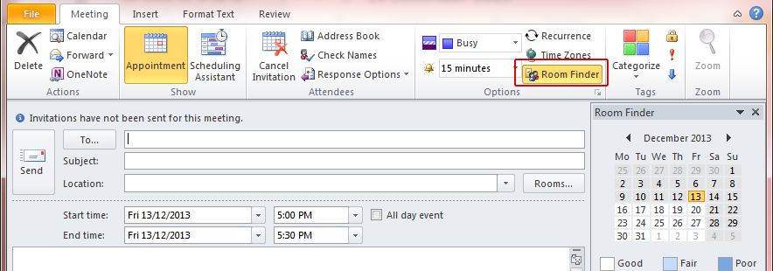

Choose **CBE Rooms** from the dropdown list.

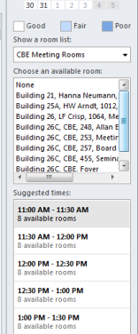

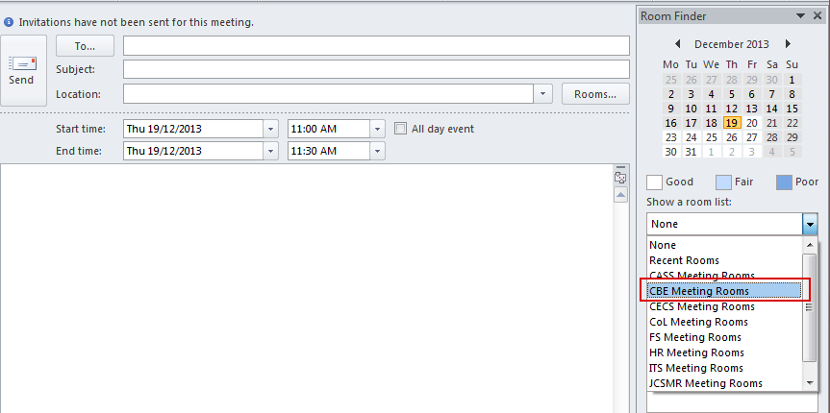

The list of available rooms will change to show only those rooms that are available.

The Room will appear in the To… field at the top of the screen, and that the Start time and End Time have been filled in automatically. Other options around that time will also show, in case your preferred room is not available for the time you want.

You can also use the scheduling assistant to check when specific rooms are available, then drag the meeting start and end times as required. You will also see the availability of other participants, if they use Outlook as their calendar.

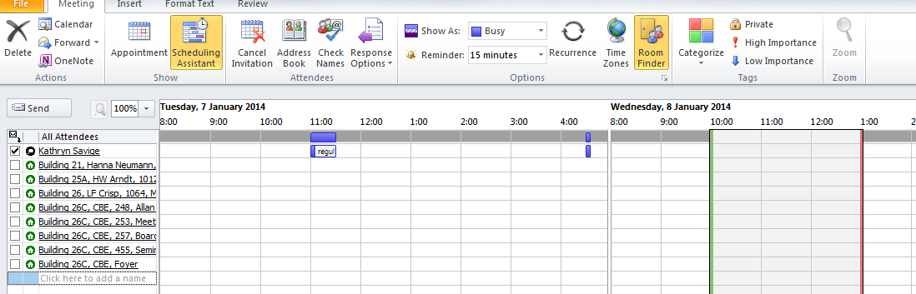

## Making the booking

If you need time to set up and/or pack up, please include this time in the booking.

Click on the room you want, which will appear in the ‘To’ field.

Please add the following information into the subject field:

* Event title and type (e.g. seminar, meeting, external group…)

Into the large field, please enter the following information:

* Contact name and phone number (if different from the organiser)
* Other requirements.

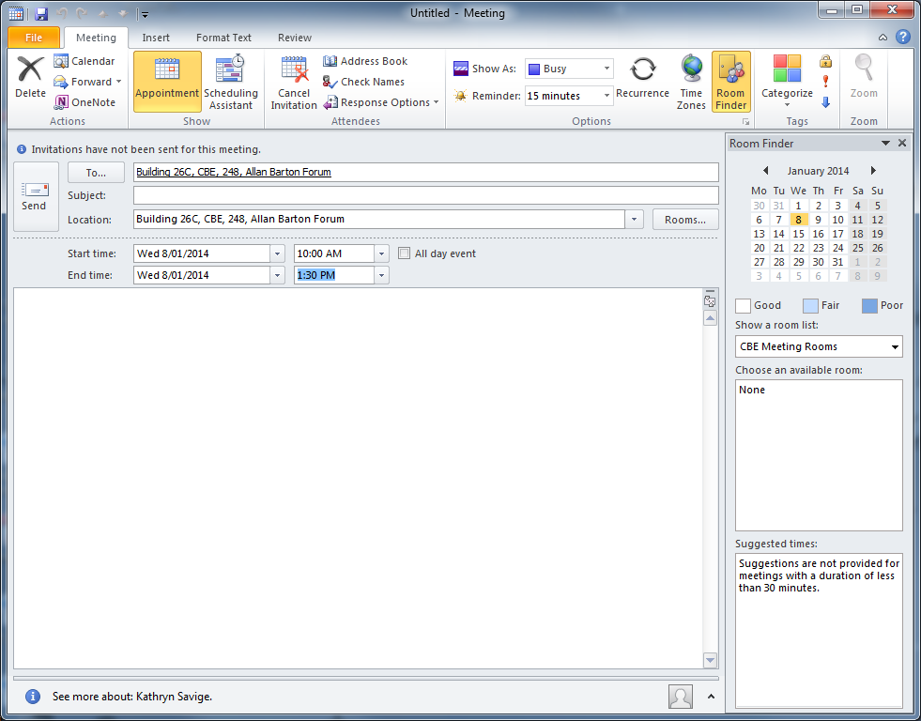

Click **Send.**